**AXIS MYZONE CREDIT CARD**

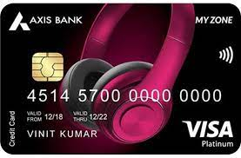

Table of Contents

Card Type/Category: 1

WOW Factor 1

Welcome Offer 2

Fees 2

Features: 2

Eligibility Criteria: 4

More about Axis EDGE REWARD Points 4

How to earn rewards on every transaction that you make? 4

How to redeem your rewards? 5

What is the best way to redeem your rewards? 5

Till when are your reward points valid ? 6

Important TnC’s 6

Value Hacks: 6

Competitor Card: 7

Offers on CK Retailers 7

Card Type/Category: Shopping + Lifetime Free

WOW Factor**:**

* SonyLiv Subscription worth Rs 999 for Free on first spend within first 30 days of card issuance.
* Buy One get One Free on movie tickets at Paytm movies. *Coupon Code*: **AXIS200.** Max. discount incalendar month per customer is limited to INR 200.
* Flat Rs. 120 off on Swiggy with MyZone card Coupon Code:AXIS120 to avail discount, applicable on Minimum spend of INR 500. Code can be redeemed twice per month per user id on Swiggy. Offer valid on all restaurants where alliance offers are applicable.
* 1 Complimentary Lounge access within India to select airports per calendar quarter.
* Earn 4 EDGE Rewards Points with every Rs 200 spent. (**1 EDGE Reward point= Rs 0.40**). For options to redeem points, check EDGE REWARD catalog: <https://edgerewards.axisbank.co.in/lms>. No reward points for movie, fuel, insurance, wallet, rent, utilities, education, government institutions and EMI transactions.
* Get up to Rs 1000 off on Ajio, on minimum spends of Rs 2999. Use coupon code “AJIOAXISMZ”. Applicable on select styles, for applicable products visit: <https://www.ajio.com/s/ajioaxismz-4998-66181?utm_source=AxisMyZone&utm_medium=alliance&utm_campaign=Upto1000>

# Welcome Offer

* SonyLiv Subscription worth Rs 999.

# Fees

**Joining Fee: Rs 500**

**Annual Fee: Rs 500**

**Features:**

1. Flat Rs. 120 on food delivery at Swiggy (twice per month) - use code AXIS120

* Max discount (per order): Rs 120
* Offer valid on orders over Rs 500
* Can be availed up to 2 times in a month.
* Offer applicable on all restaurants orders where Alliance offers are applicable
* Alliance offers include all third party offers including Bank/Wallet/ Fintech/partner offers.
* This offer is not applicable on Haldiram’s restaurants all across India.

1. Buy 1 Get 1 Free on movie tickets

* Get 100% discount on the 2nd movie ticket at Paytm Movies using this card
* In a month a user can avail Max discount of Rs 200, consisting of all transactions made in that month. Regardless of the number of transactions that he makes, he can only avail Rs 200 as the max discount.
* Use code **AXIS200** to avail this offer.
* No rewards will be earned on this transaction.

1. Enjoy 1 Complimentary Lounge Access to select Airport lounges within India per calendar quarter.
2. Dining Delights

* Get 15% off (upto Rs. 500) at partner restaurants , MOV: Rs. 2500
* Valid once per card per month
* Dining Delights Program by EazyDiner: <https://www.axisbank.com/docs/default-source/default-document-library/credit-cards/dining-exlusive-program-tnc.pdf>

1. Complimentary SonyLiv Premium annual subscription Free

* Get SonyLiv annual worth Rs 999 for Free within 30 days of card issuance.
* Eligible customers will receive SonyLiv subscription voucher code via SMS on registered number and Email id within 45 days of card issuance.
* Subscription renewal on spending 1.5 lakhs in a card anniversary. Only applicable on paid cards.
* For subscription renewal, eligible customers will receive the code via SMS and email within 60 days of payment of annual fees.

1. Upto Rs 1000 Off on Ajio

* Get upto Rs 1000 off on Ajio orders over Rs 2999
* Use code **AJIOAXISMZ** to avail this offer.
* Offer applicable on styles available on the following page

<http://www.ajio.com/s/axismyzone-1611228869>

* Offer is valid once per quarter.
* Click here for details <https://www.axisbank.com/Docs/Default-Source/Default-Document-Library/Credit-Cards/Terms-And-Conditions-For-Ajio-Offer-For-My-Zone-Credit-Card.Pdf>

1. Enjoy complimentary lounge access.

* Enjoy 1 complimentary lounge access (Domestic)
* Valid once per quarter
* [List of Airport](https://www.axisbank.com/docs/default-source/default-document-library/axis-bank-airport-lounge-access-program.pdf)

1. Fuel up and get a waiver on surcharge

* 1% fuel surcharge waiver on all fuel transactions in India
* Appliable on transaction between 400-4000.
* Maximum benefits upto 400 per cycle
* GST charged on fuel surcharge is non-refundable

1. Earn 4 EDGE REWARD points with every Rs 200 spent on the credit card

* Rs 200 = 4 Edge Rewards
* **1 RP= Rs 0.40**
* No reward points for movie, fuel, and EMI transactions
* These rewards can be redeemed against the following catalogue - <https://edgerewards.axisbank.co.in/lms/>

# Eligibility Criteria:

* Must haves
  + Age: 21-65Years
  + Monthly Income: Salaried = Rs 21K & Self Employed = Rs 30K
  + Applicant should be resident of India
  + Credit Score – 650+
  + New to Credit – Allowed
* Docs Required
  + Valid Pan Card
  + ID Proof
  + Address Proof
  + Income Proof – Bank Statement or/and Salary Slip
  + No Delay Payments in last 12 months

TnC’s - https://www.axisbank.com/retail/cards/credit-card/axis-bank-my-zone-credit-card-old/eligibility-documentations

* Good to have
  + Existing active credit card with limit >50,000 (of any bank, as it helps in card-to-card approval)
  + Existing Home or Auto Loan

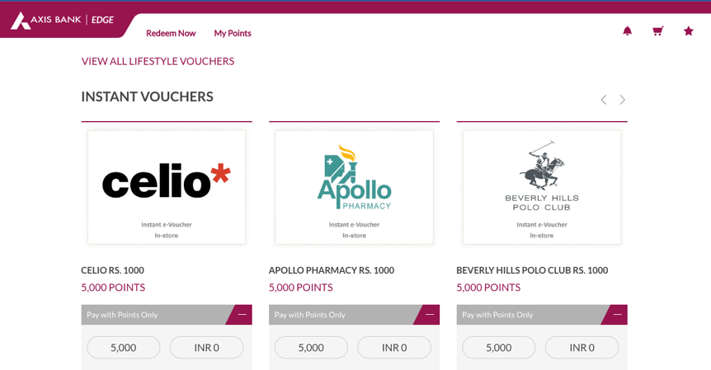

Catalogue link for rewards redemption- <https://edgerewards.axisbank.co.in/lms/>

Competitor Card:HDFC Millenia Credit Card